CS 255 System Design Document

UML Diagrams

UML Use Case Diagram
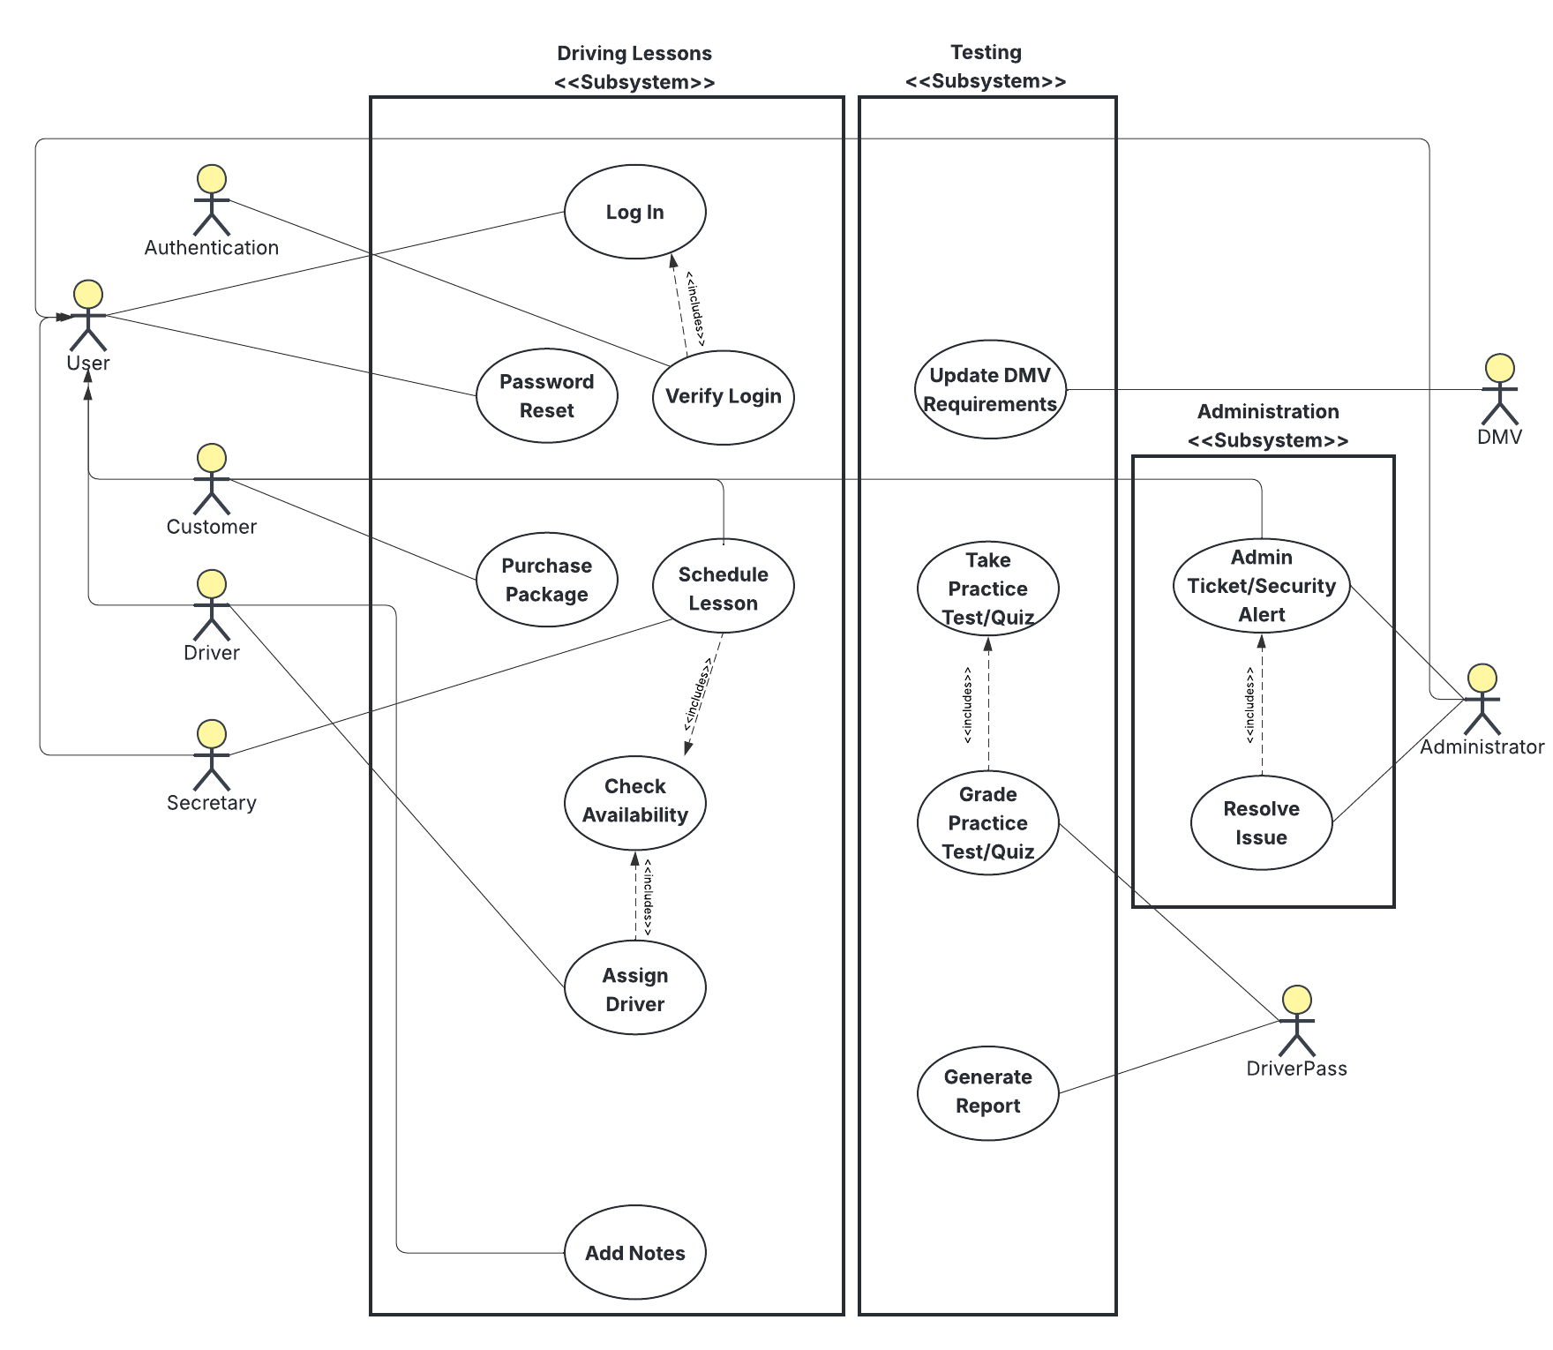

UML Activity Diagrams
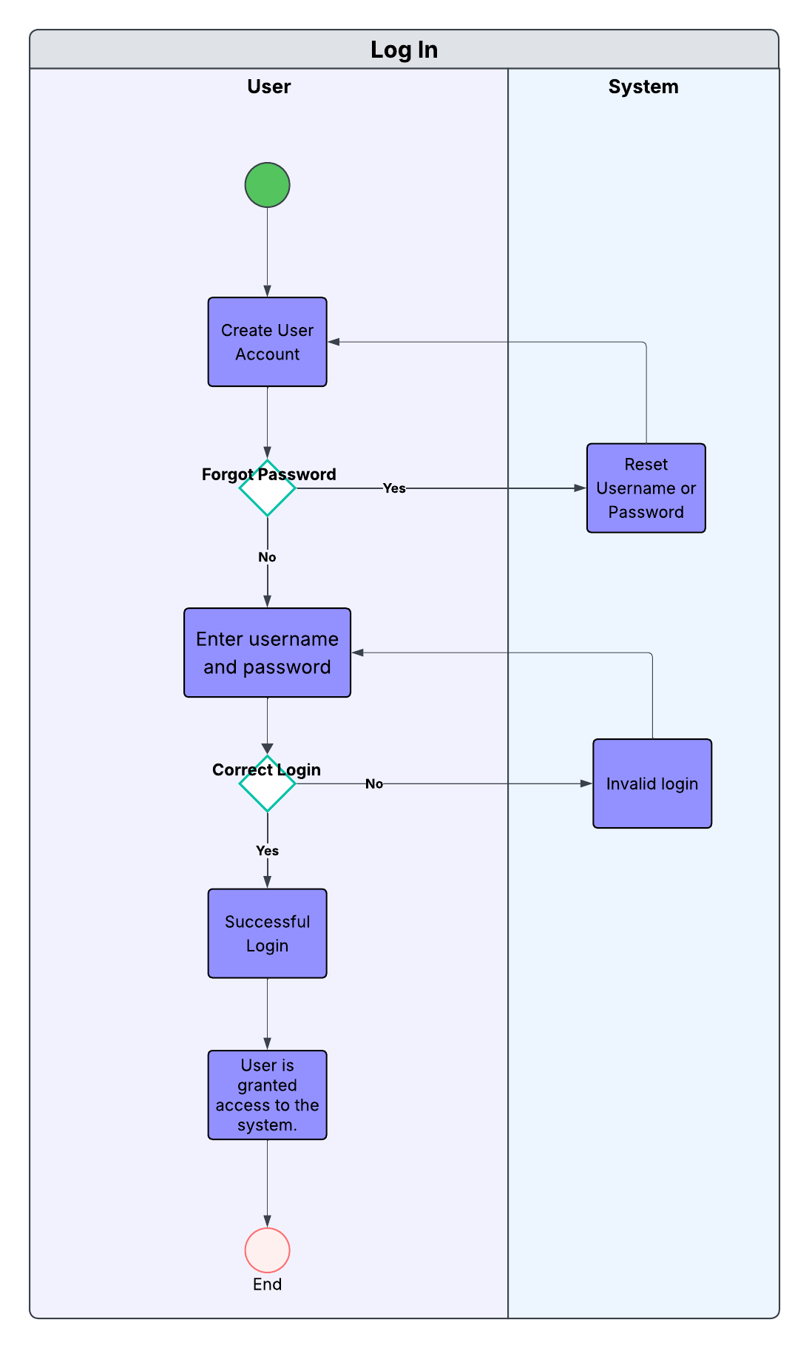
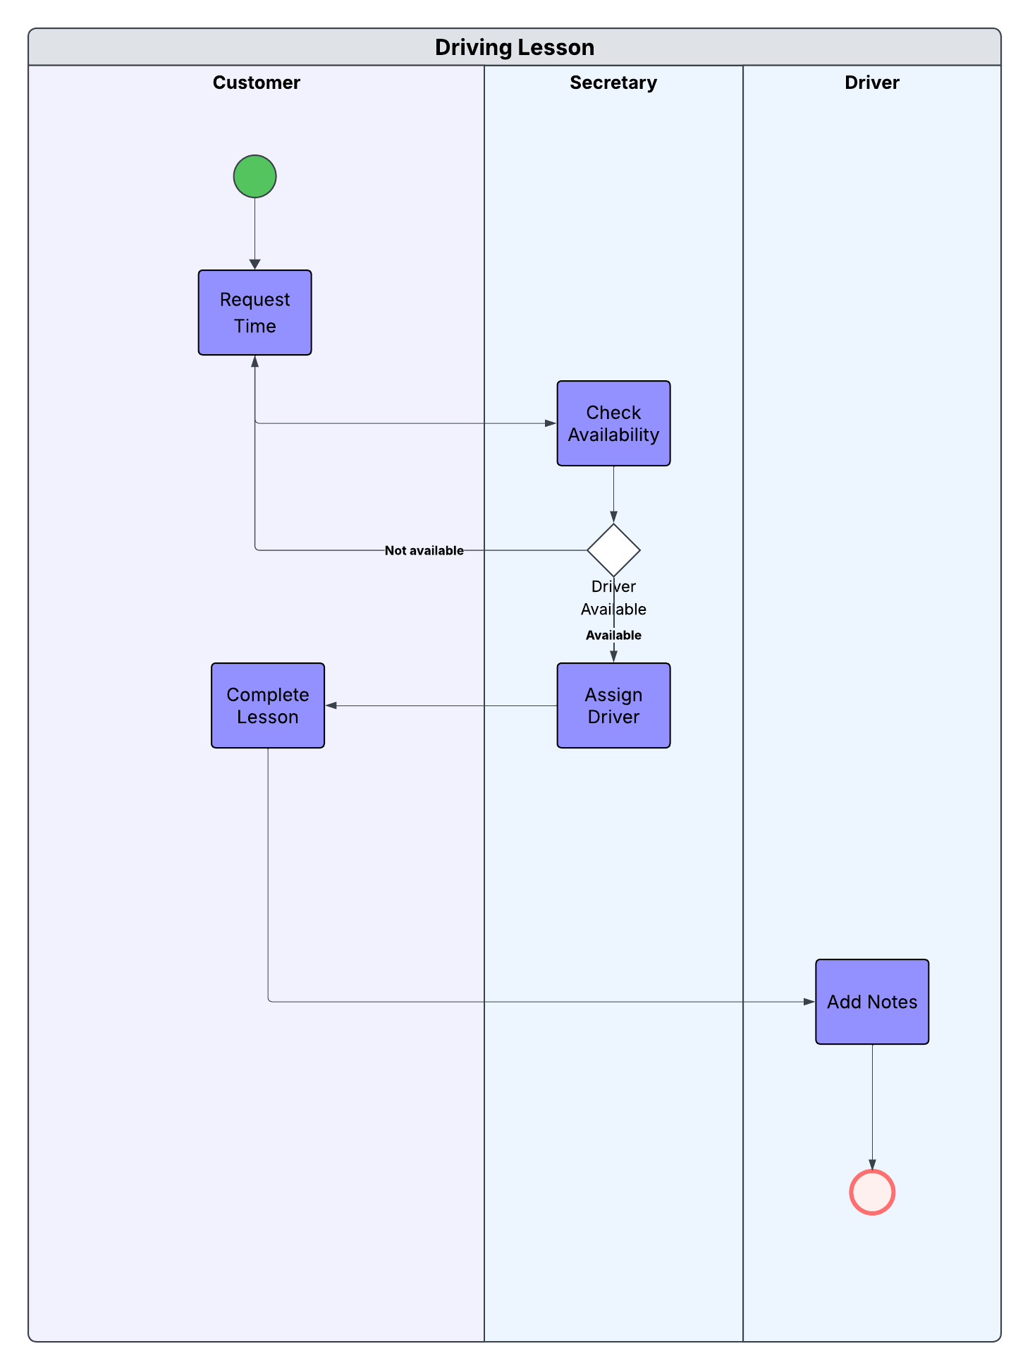

UML Sequence Diagram
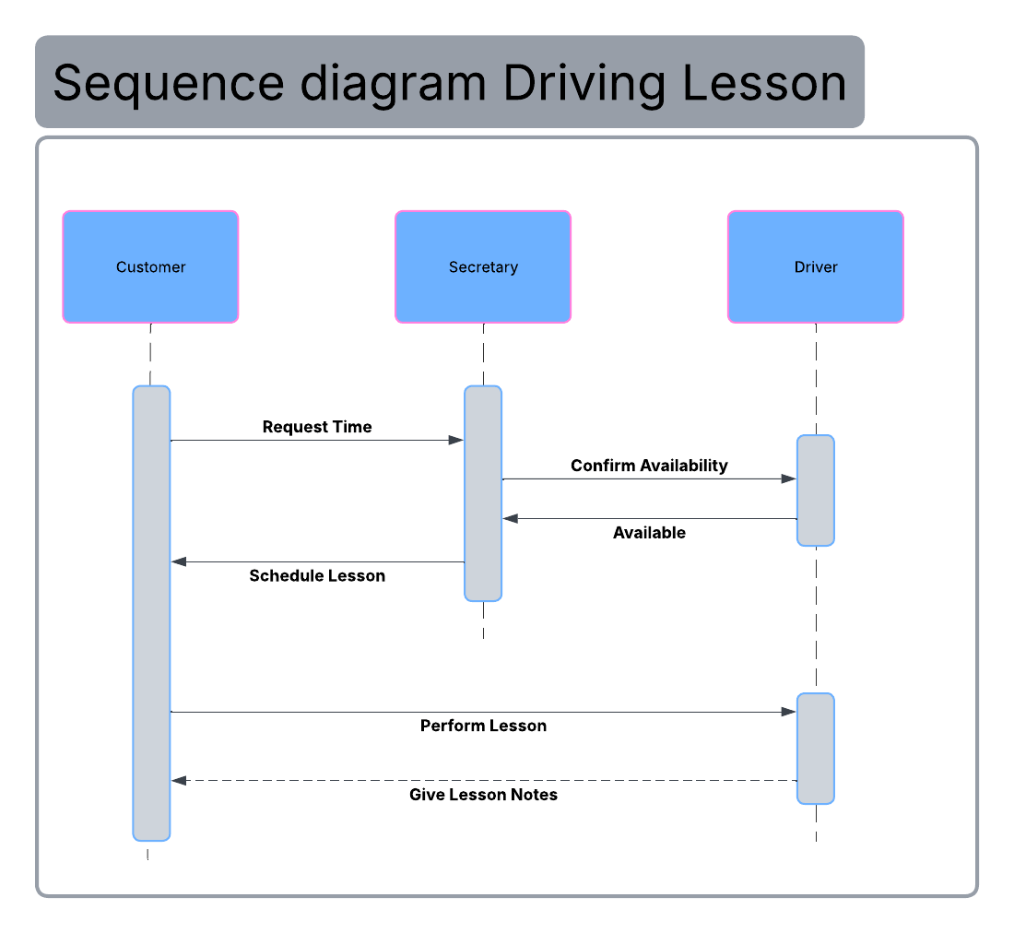

UML Class Diagram
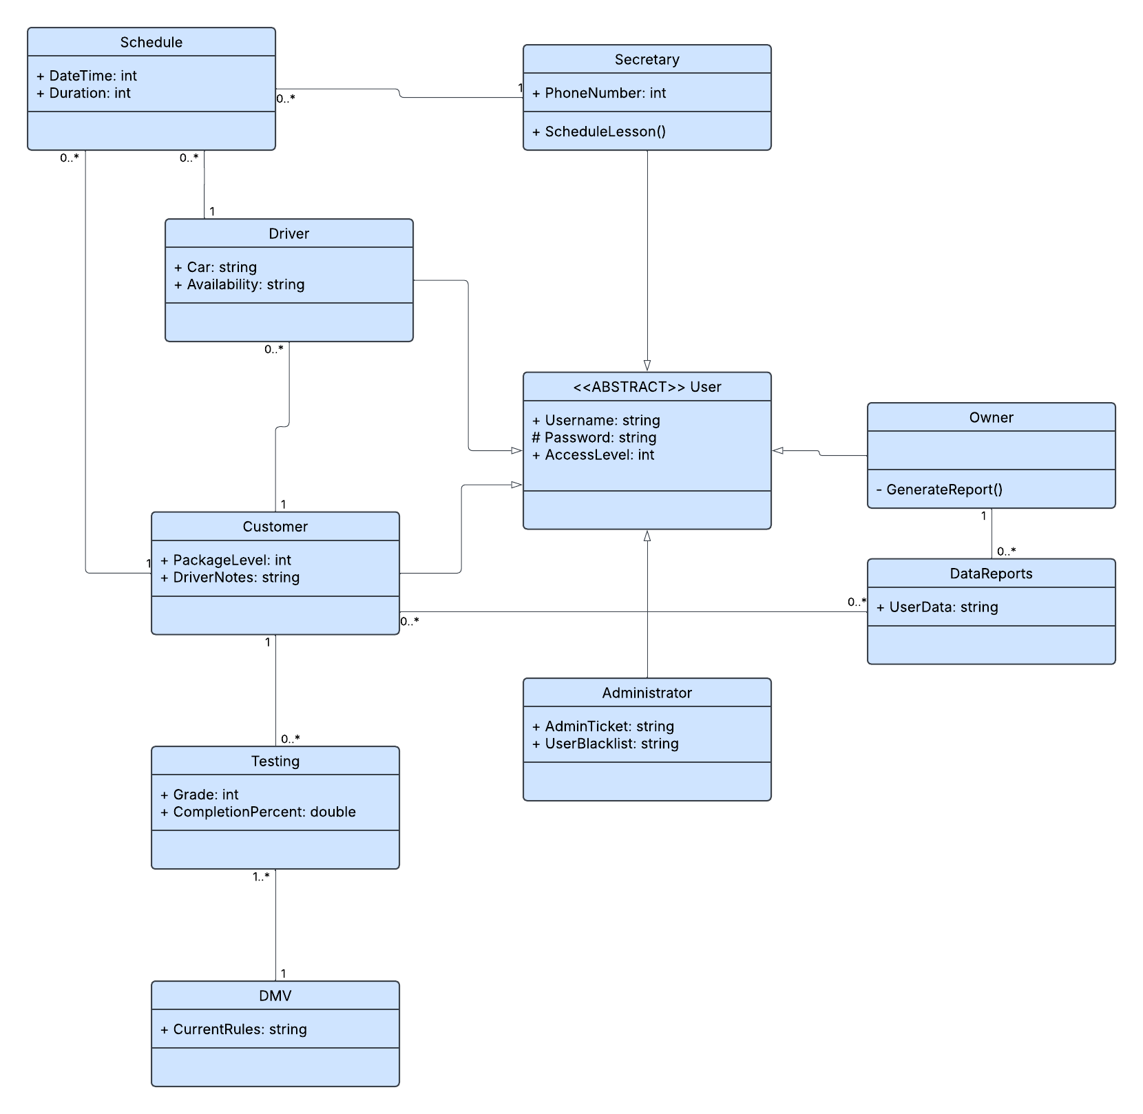

Technical Requirements

- Hardware
  - An internet connected computer with peripherals.
  - Phone.
- Software
  - Windows operating system, most up to date version.
  - Cloud based storage solution.
  - Excel compatible log.
  - AES-256 encrypted personal information.
  - API key with DMV requirements.
  - E-Receipt for package purchases.
  - Login authentication.
- Geographical
  - Lessons can only be taken in the United States.

